Short Visual Studio Ability Demonstration

Because we primarily use Visual Studio and heavily use Windows Forms and User Controls, we are requesting that you make a quick sample project to show that you are able to work with Visual Studio and use Windows Forms and User Controls.

Please make a small Ability Demo application.

1. It must include the Visual Studio project and solution so we can quickly verify it is done as requested
2. It must be a Windows Form Application
3. It must open a Windows Form when run
4. It must have two User Controls
5. It must have two buttons to **add** / **remove** each user control
6. When clicking Add UC1 or Add UC2 the corresponding control must be added to the form and the button text changed from Add to Remove for that button
7. When clicking Remove UC1 or Remove UC2 the corresponding control must be removed from the form and the button text changed from Remove to Add for that button

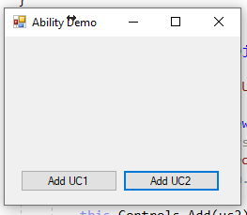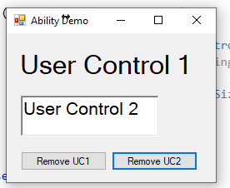

Important notes:

1. The control must be added to the form / removed from the form when the button is clicked, not added in the designer and then shown / hidden when the button is clicked.
2. The form must allow showing no controls, UC1 only, UC2 only, or both UC1 and UC2

Short Application

Full Name: David Walker

Home Address: 209 Crescent Oak, Peachtree City, GA, 30269

List all States/Countries you would be working from:  
Georgia/United States

What relevant, practical, programming experience do you have (from work and/or hobbies)?  
3-month internship, Summer 2021

* Front-end development: Angular/Typescript
* API: C# and NGRX
* Database: SQL
* Git and Microsoft DevOps

C coding with an Arduino UNO

What is the programming project you’re most proud of, what was your involvement, and how long did it take?  
My senior year capstone project in college. The project was a trip planner app with a web and desktop versions. I worked mostly with our desktop version doing full stack development and UI design. This project took the entire semester of Spring 2022

What is the worst programming project you’ve been involved with, why is it the worst, what was your involvement, and what would you do differently?  
In my Intro to DevOps class, I did a group project creating a Healthcare app in Java. There was a lot of decisions and implementation that I was not involved in or told about, leaving me kind of in the dark when we did a demo on it.

Have ever plead no contest, nolo, or guilty to a crime, or convicted of a crime? NO

If yes, please explain:  
__________________________________________________________________________________________________________________________________________________________________________

Is your resume attached? Yes

Is it complete and accurate? Yes

Is the requested Windows Form project attached? ____________________________________________

Is it entirely your work? Yes

**I certify that the information given by me on this application and during the interview process is true and complete in all respects, and I agree that if the information is found to be false, misleading, or unsatisfactory in any respect (in the Company’s judgment) that I will be disqualified from consideration for employment or subject to immediate dismissal if discovered after I am hired.**

Please sign and date that this is your work history, and that it is complete and accurate, then email it back.  
Sign: David Walker Date: 7/7/2022

